Coffe Shop

SE 352 – Object Oriented Enterprise Application Development

SE 352 Project

**Contents**

Overview

Requirements

Use Case

Description of problem

Design

Sequence of major functionality

[Web UI (Common Case)](#_Web_UI_(Common_1)

Table layout

Deployment

Discussion of how your design met the requirements

Discussion of lessons learned

Decision log

Milestone Screenshot

# Overview

This is a web application for an imaginary coffee shop. It will allow users to select, view, buy and edit selected products. It would also allow registration for new customers and a log in for existing customers.

# Requirements

## Use Case



Users want coffee or sweets and order them through the application. The order is received and purchased, and the users get satisfied.

## Description of problem

Coffee shop application that allows clients to purchase the shop’s products.

# Design

## Sequence of major functionality

***For MYSQL:***

* Download MYSQL.
* Start the server.
* While the server is running you can operate with your database.

***Application.properties:***

Here is the configuration of the “application.properties” to connect to the database. Using

*# Configuration for the datasource***spring.datasource.driver-class-name**=**com.mysql.jdbc.Driver  
spring.datasource.url**=**jdbc:mysql://localhost:3306/coffeeShop_schema?serverTimezone=UTC&useSSL=false&allowPublicKeyRetrieval=true  
spring.datasource.username**=**root  
spring.datasource.password**=**julio123***# Configuration for Java Persistence (JPA)  
#Will show the SQL statements being executed.***spring.jpa.show-sql**=**true  
spring.jpa.properties.hibernate.dialect**=**org.hibernate.dialect.MySQL5Dialect  
spring.jpa.hibernate.ddl-auto**=**update**

### Web UI (Common case)

**Front Page (home) 🡪 localhost:8080/home or localhost:8080/home**

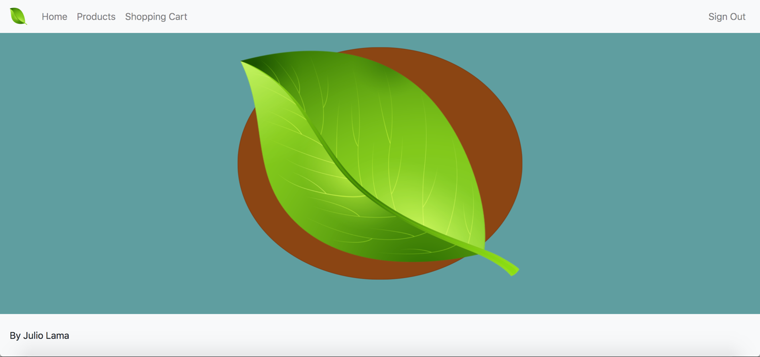

* Products and Shopping Cart at the moment are empty pages that can be requested like this:

**Products:** *localhost:8080/products*

**Shopping Cart:** *localhost:8080/shoppingcart*

**Home:** *localhost:8080/home & localhost:8080*

## Table layout

* I also have a Schema in MYSQL called “**coffeeShop_schema**”.
* JPA creates the tables automatically.

## Deployment

* Download the code.
* Set up a MySQL configuration.
  + Go to application.properties file.
  + Change the host of the datasource to yours. Mine was localhost:3306
  + Change the username to yours.
  + Change the password to yours.
* Run the application.
  + Should be running on localhost:8080

# Discussion of how your design met the requirements

* Right now, my design meets the requirement of a Java Enterprise application thanks to the Spring framework. Uses the Model Viewer Controller (MVC) design pattern.
* Framework uses Controllers / Servlets
* Framework was configured to use Java Server Pages (JSP) as the view.

# Discussion of lessons learned

**Lessons Learned Milestone 2:**

* Learned how to use a database client such as MongoClient to connect to a database.
* Learned how to map Java classes to Collections in the database as *Documents*.
* Learned how to *query* Documents from the Mongo database.
* Downloaded a plug-in on IntelliJ IDEA that gave me a GUI for my Mongo database. This GUI is called “MongoExplorer”.
* Learned how to connect my application to MYSQL.
* Learned how to map Entities to Java classes.

**Lessons Learned Milestone 3:**

* Learned how Servlets get called by a web server to fulfill a request made by the client.
* Learned about the Model View Controller (MVC) design pattern used in web applications.
* Learned how Java Enterprise web applications implemented the Model Viewer Controller initially and how “coupled” it was initially.
* Learned about Spring MVC framework that leverages the implementation of the Model Viewer Controller design pattern while following the same architecture (Servlets, JSP, Application Server).
* Learned about the folder structure of a web application when it is packaged as a WAR project.

**Lessons Learned Milestone 4:**

* Learned how to work better with Model and View using Spring MVC.
* Learned a little bit of how to track a user session and make the web application interact with the user that is currently in that session.
* Learned how to “connect” the front-end and back-end, through inputs, forms, buttons and controller method calls from the UI.

**Milestone 4 Screenshot**

**Identifying a User through HttpSession in Spring:**

1. **We change the scope of the POJO:**



1. **We use dependency injection on our controller, so we can use it:**



We “fill” the POJO Customer by using a registration form and after that we store it in a session:



Now we can use the current customer anywhere in our controller.

Now every time the customer logs in and exists in the database, the web application is aware of it.

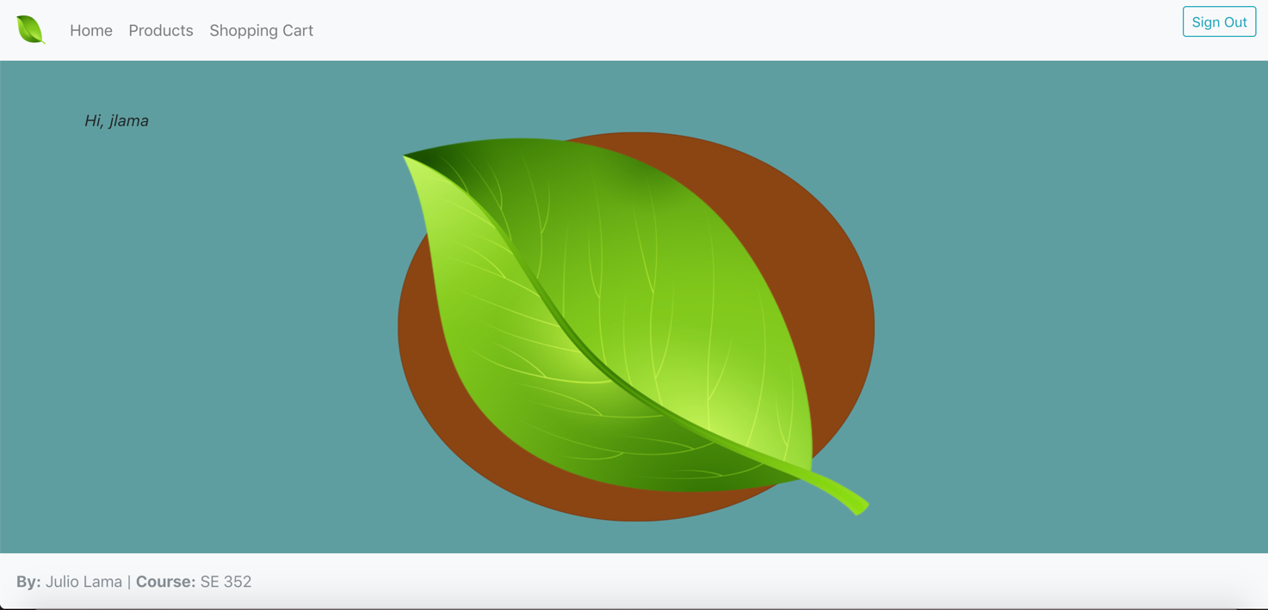

The “Sign Out” button just destroys the session by doing a “*session.invalidate()”*.

By knowing the specific customer, using Http session, I know to which customer I should add or delete an Order.

**Side Note:** I tried to implement Spring Security so that the project can have an actual and real “log-in” and “log-out” feature but I encountered errors with my Spring data JPA. I decided to not add Spring Security for this Milestone, might try again for the next one.

The ordering for a coffee is all hard-coded and it is not completed. You can add or remove just coffee from the shopping cart. The rest is not completed yet.

# Milestone 3 Screenshot

The following pictures represent the state of my application that is following the standards of the Spring framework.

**ApplicationContext / Configuration file (Java configuration way):**

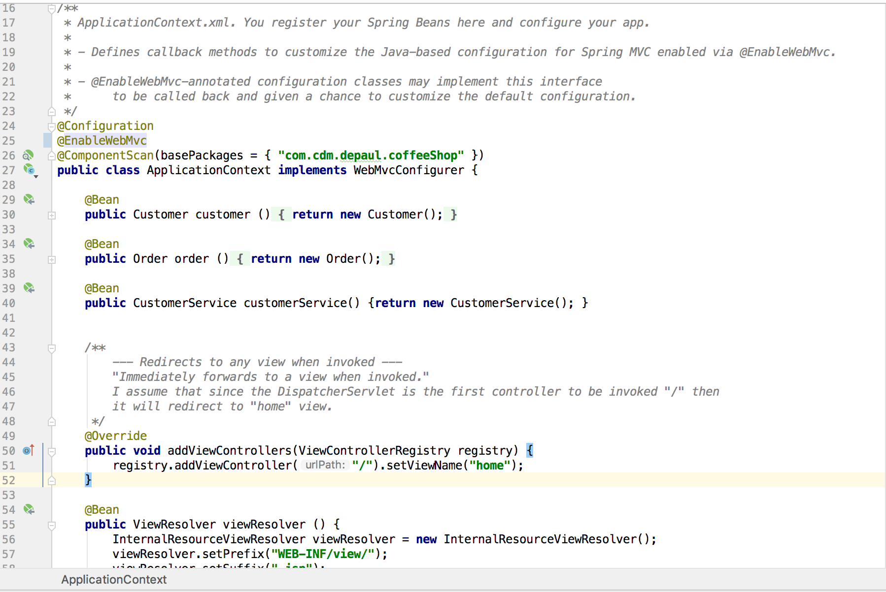

**Front Controller / Dispatcher Servlet Configuration (Java Configuration way):**

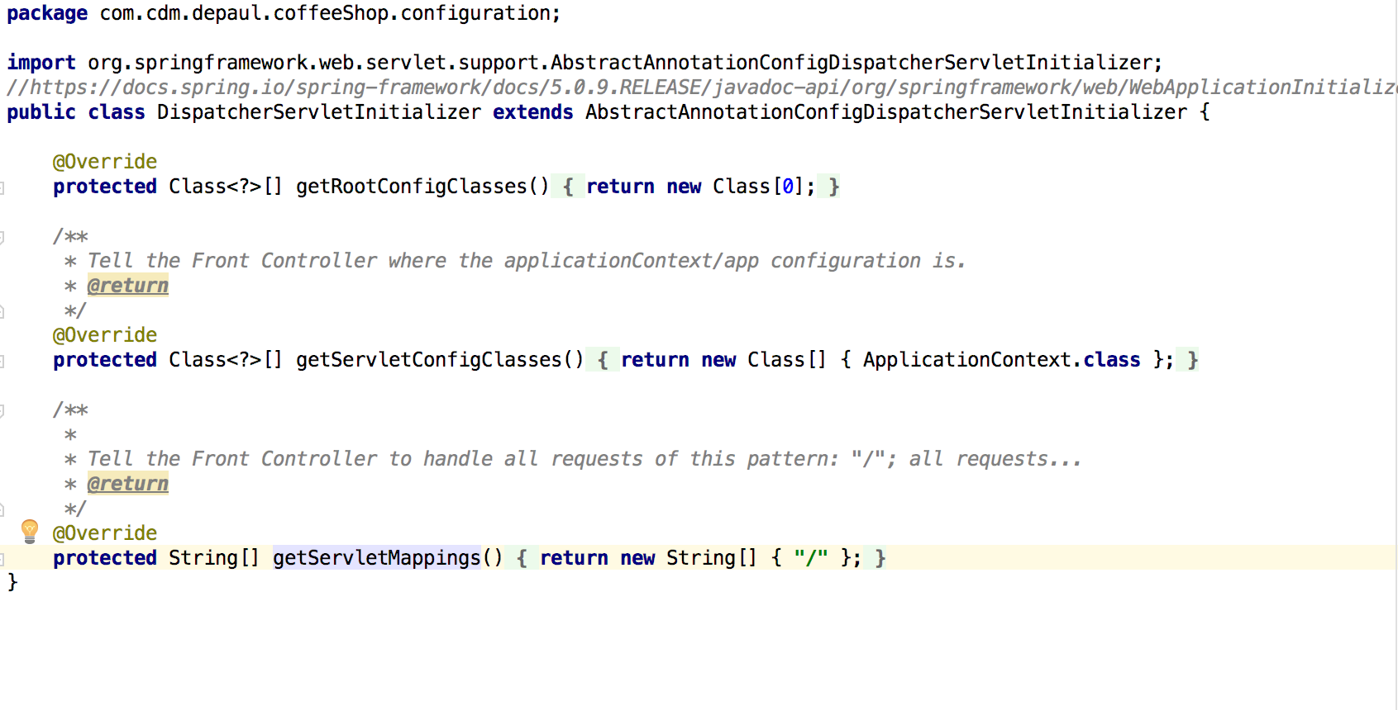

**Inserting Customer and Order to tables using Spring Data JPA:**

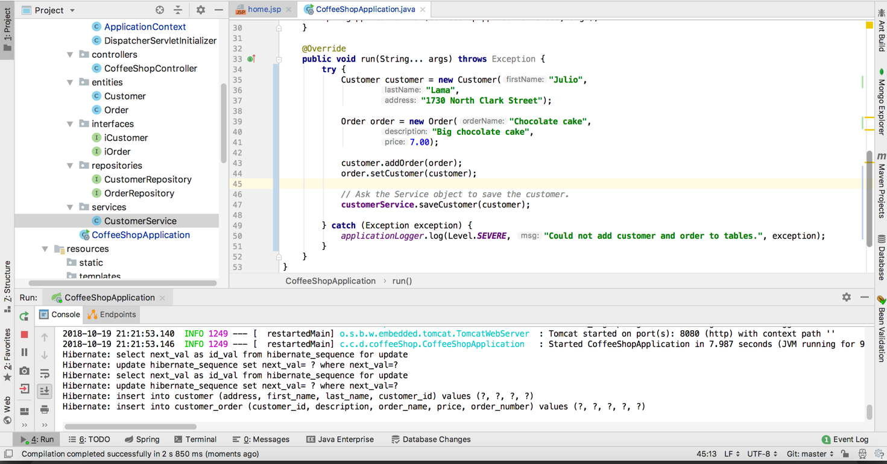

**Controller (one at the moment) state:**

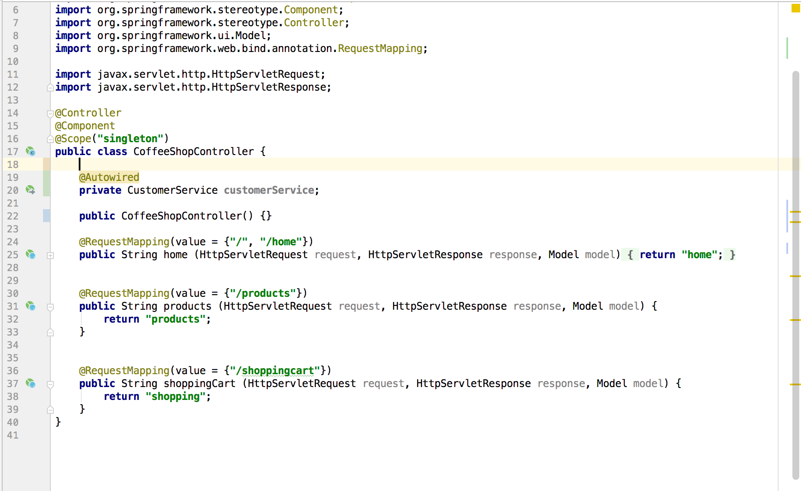

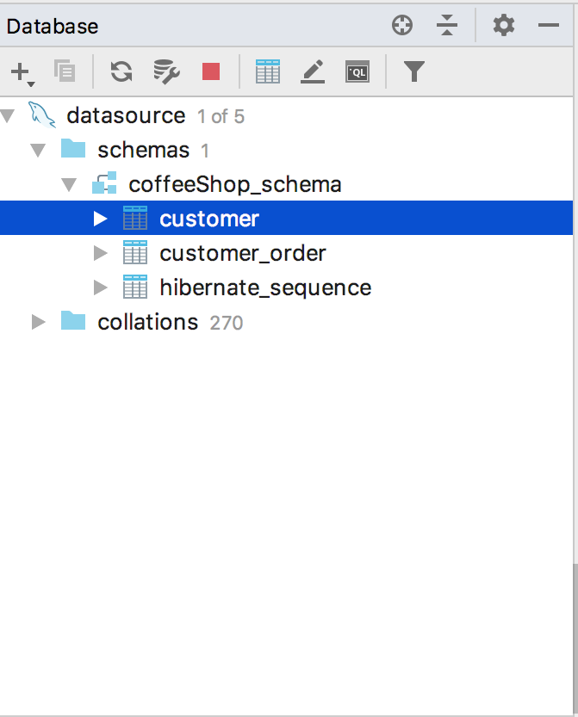

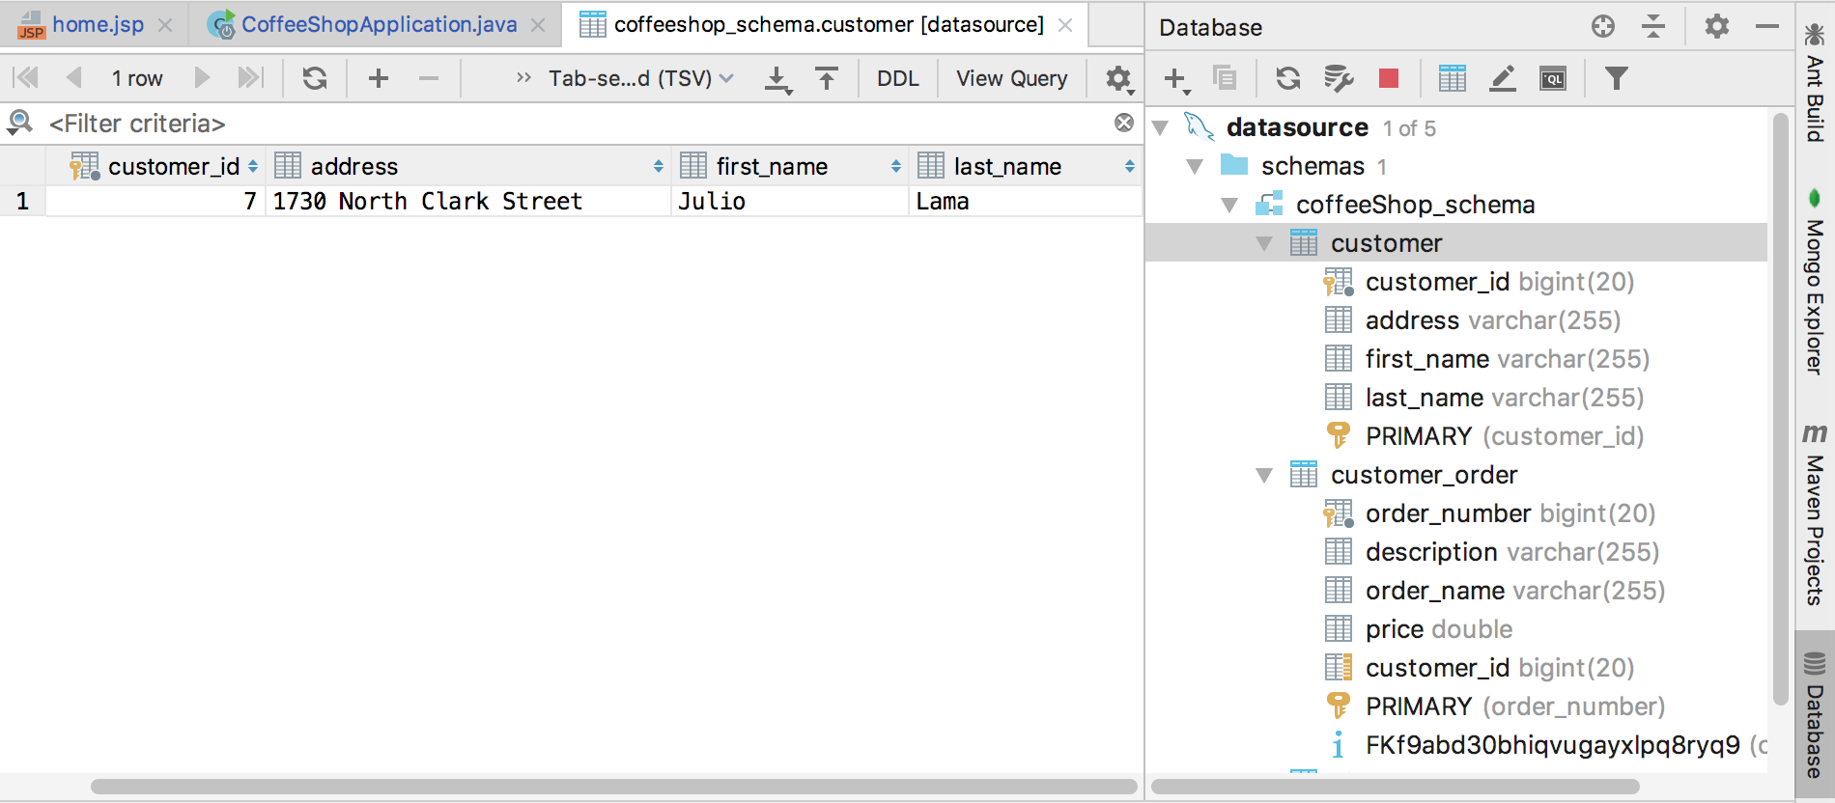

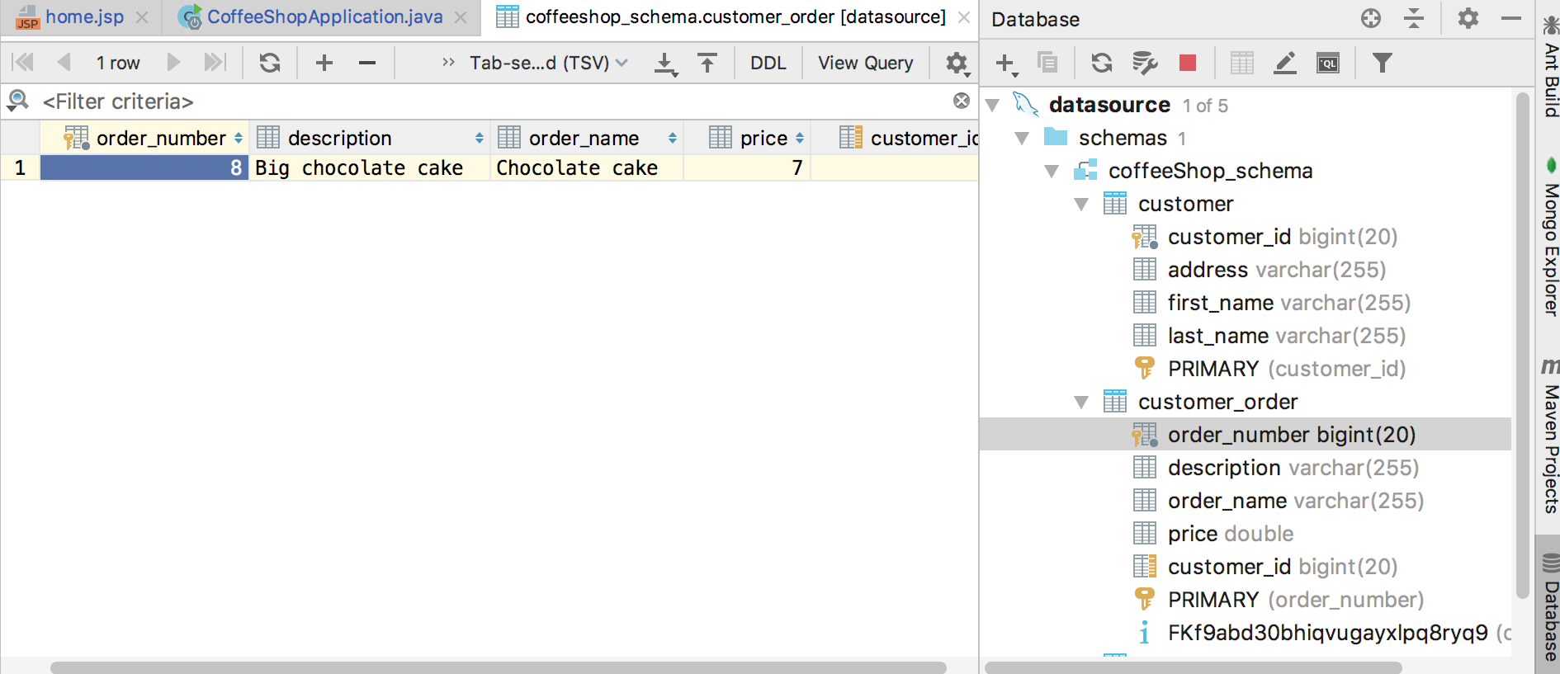

# Milestone 2 Screenshot

I changed my database to be just a relational database. Check out pictures from Milestone 2 to notice the changes.

**Database is empty/ 0 collections:**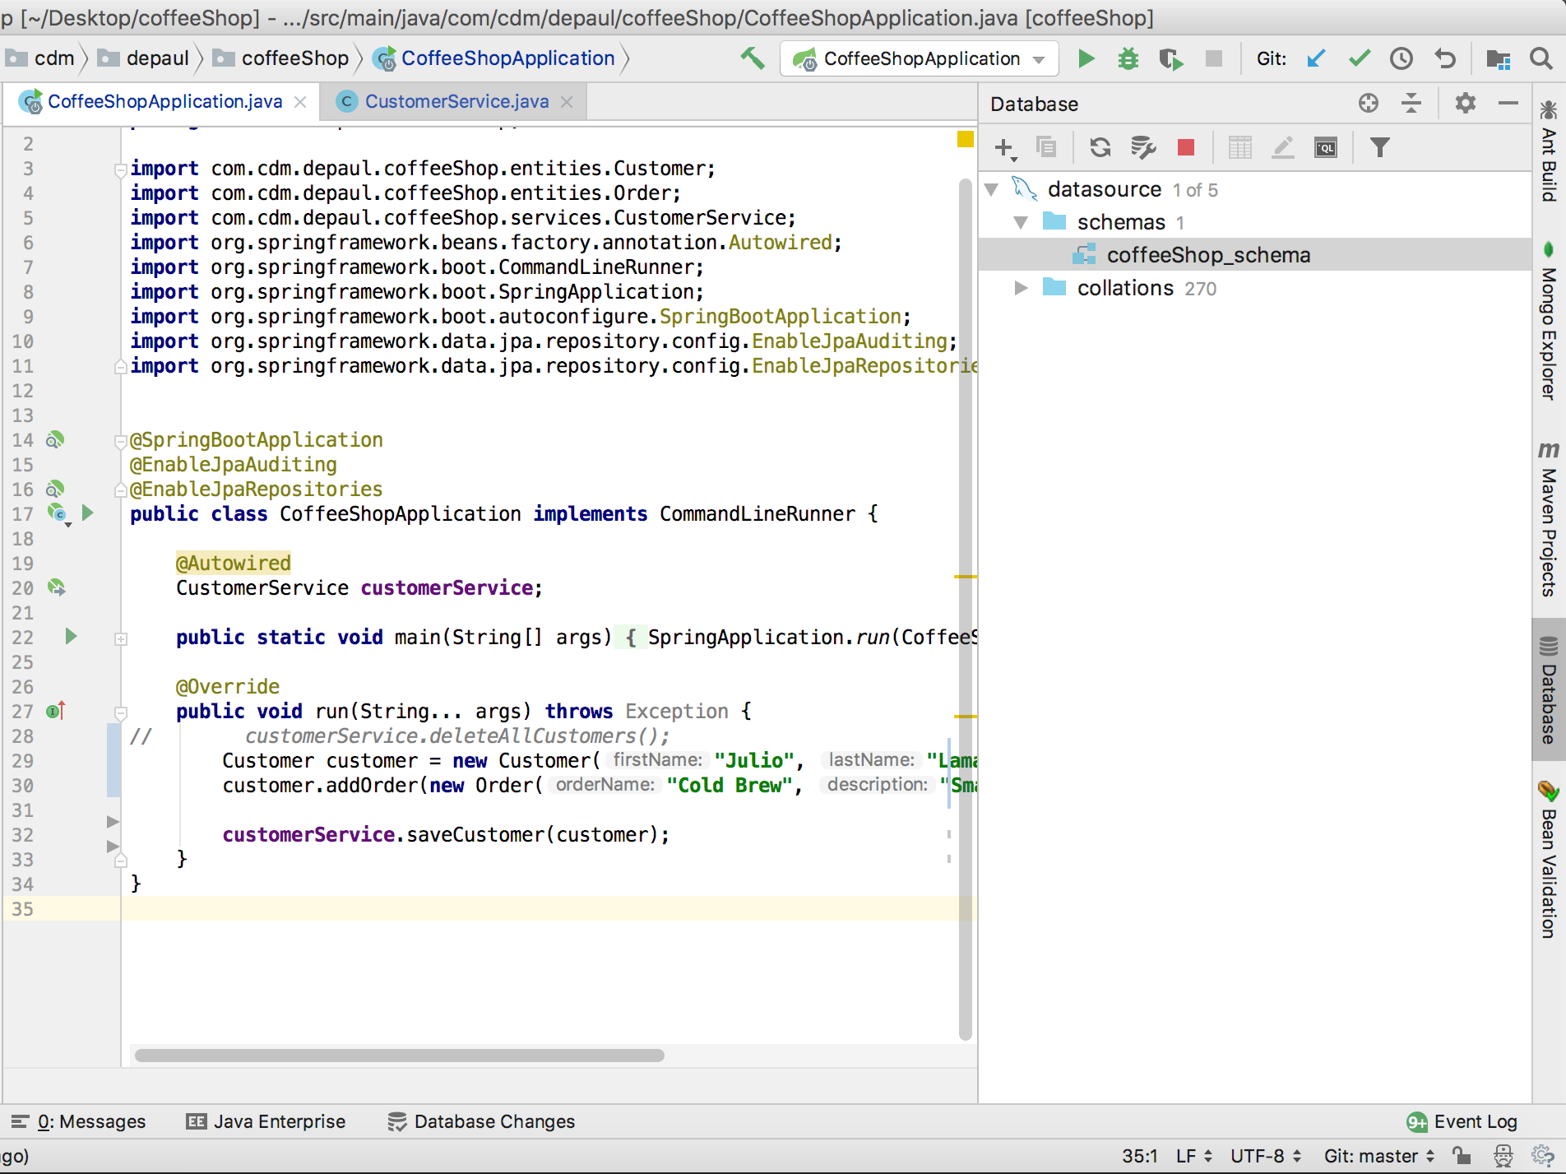

**Insertion code:**

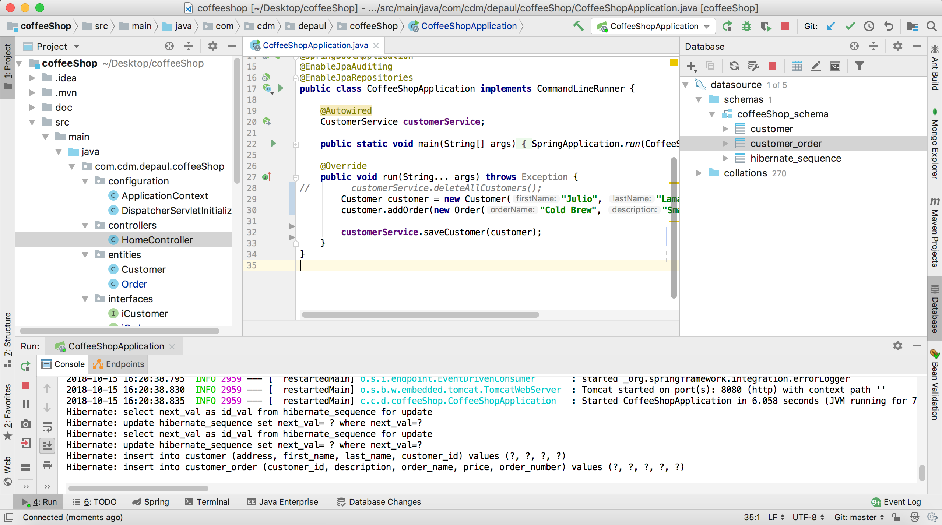

**Tables:**

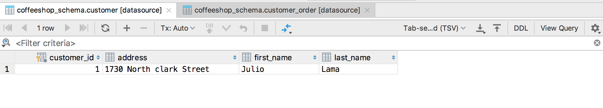

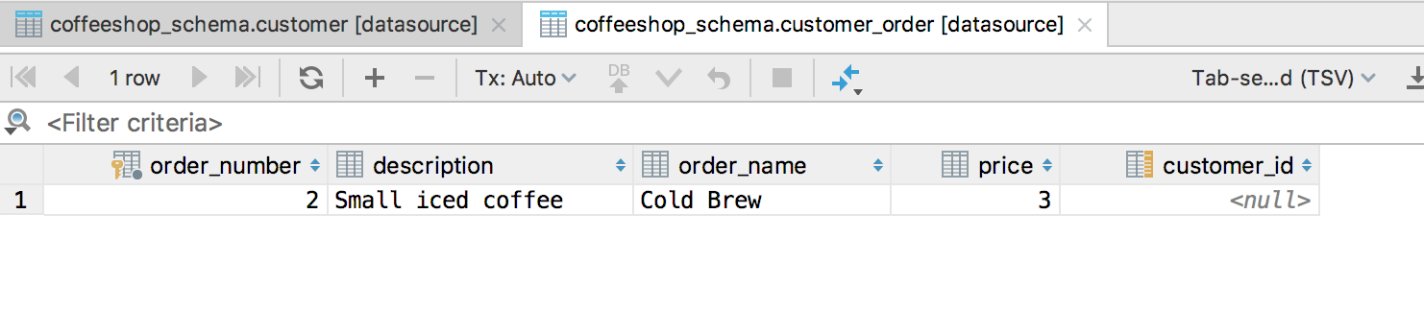

# Milestone 1 Screenshot

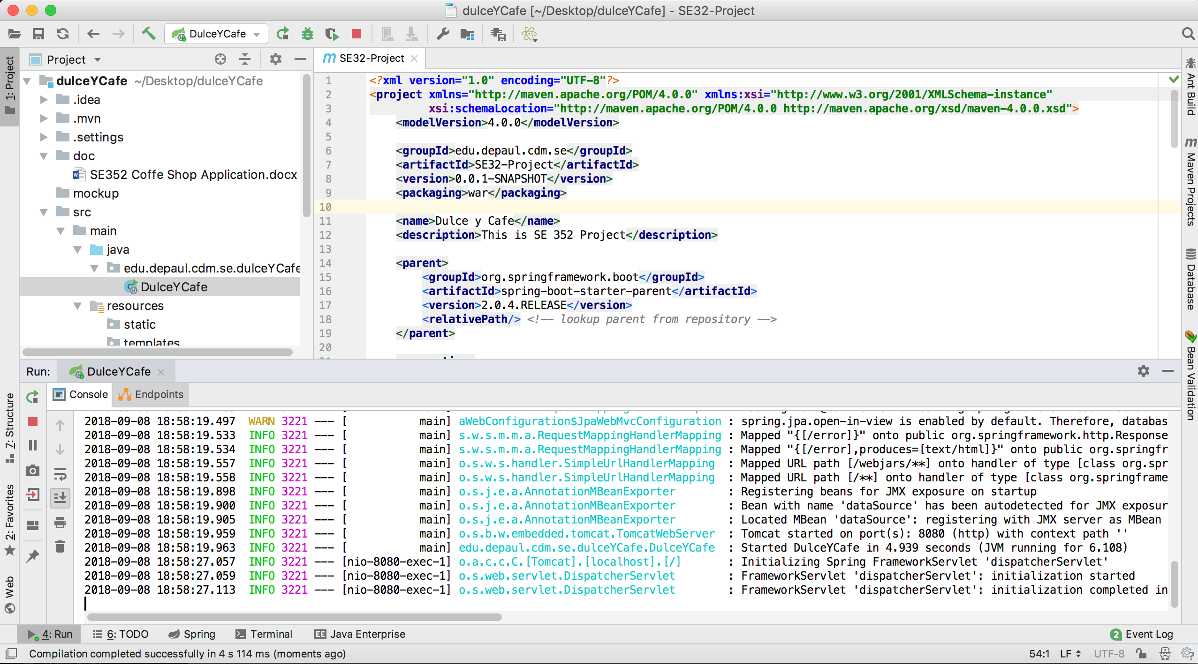

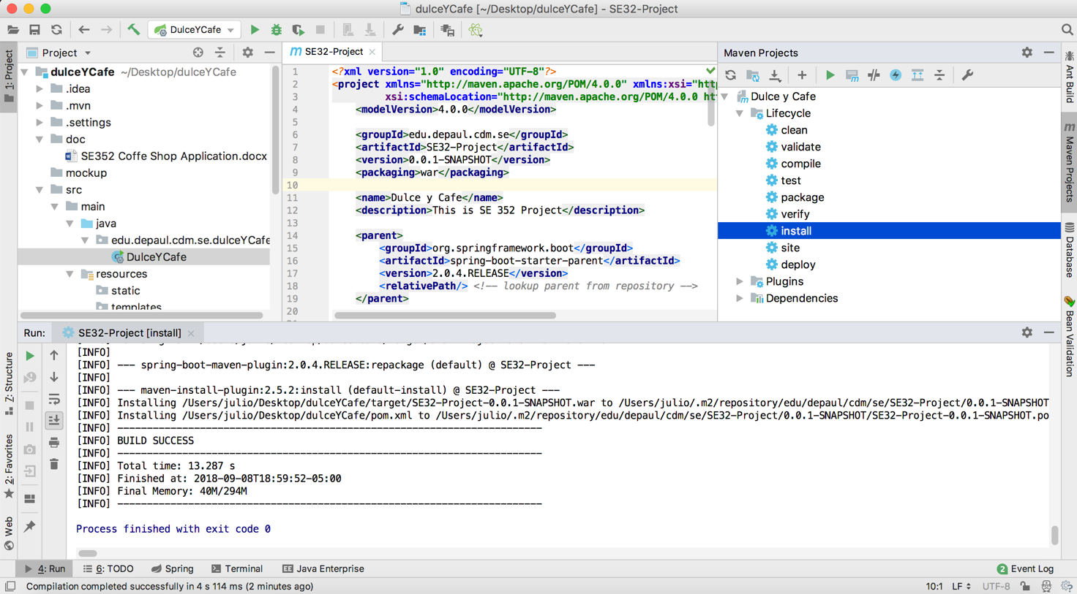

# Decision Log

|  |  |  |  |
| --- | --- | --- | --- |
| **Problem** | **What was decided** | **Alternatives considered** | **Rationale** |
| Which IDE to use | IntelliJ IDEA | Eclipse | IntelliJ is a very good IDE |
| Collaboration | Alone | Course provided |  |
| Code repo | Github | Course provided | It is available on the web. |